Group B: Assignment No 2
MongoDB - Aggregation and Indexing:

Design and Develop MongoDB Queries using aggregation and indexing with suitable example using MongoDB.
1. Create Collection Employee and insert following documents into it
> db.employee.insert({'custID':'A123','Amount':500,'status':'A'})

> db.employee.insert({'custID':'A123','Amount':250,'status':'A'})

> db.employee.insert({'custID':'B212','Amount':200,'status':'A'})

> db.employee.insert({'custID':'A123','Amount':300,'status':'D'})

2. Display records
db.employee.find().pretty()
{
"_id" : ObjectId("53d093599c406c0509bc5f89"),
"custID" : "A123",
"Amount" : 500,
"status" : "A"
}
{
"_id" : ObjectId("53d093829c406c0509bc5f8a"),
"custID" : "A123",
"Amount" : 250,
"status" : "A"
}
{
"_id" : ObjectId("53d093a69c406c0509bc5f8b"),
"custID" : "B212",
"Amount" : 200,
"status" : "A"
}
{
"_id" : ObjectId("53d093c49c406c0509bc5f8c"),
"custID" : "A123",
"Amount" : 300,
"status" : "D"
}

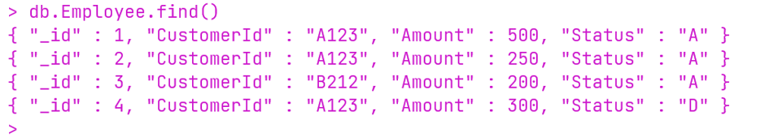

3. Find out total amount for individual customer ID having status ‘A’

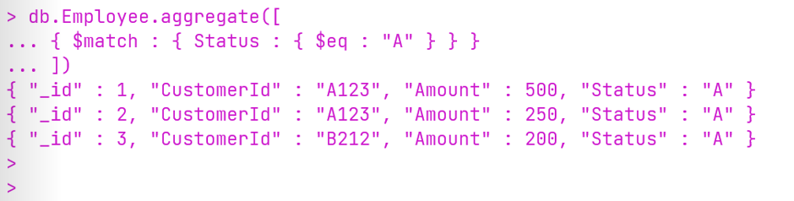

4. Find out minimum amount for individual customer ID having status ‘A’

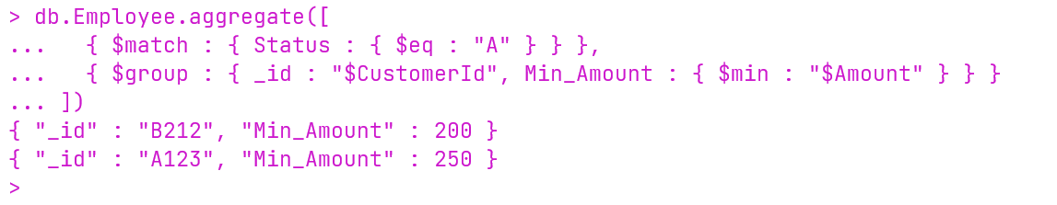

5. Find out maximum amount for individual customer ID having status ‘A’

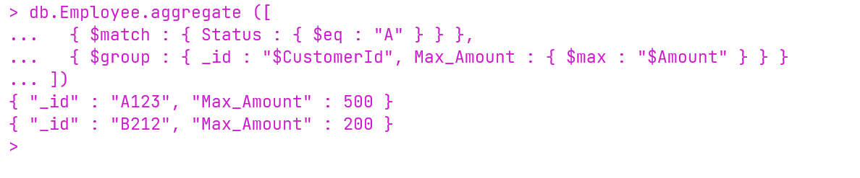

6. Find out average amount for individual customer ID having status ‘A’

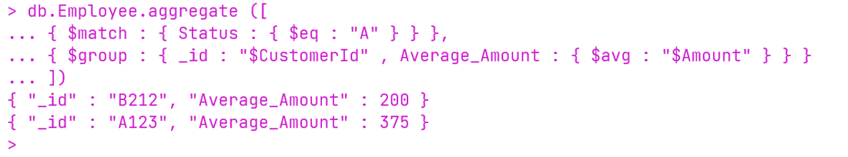

7. Find out amount of First record for individual customer ID having status ‘A’

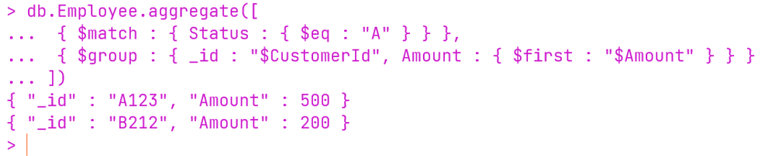

8. Find out amount of last record for individual customer ID having status ‘A’

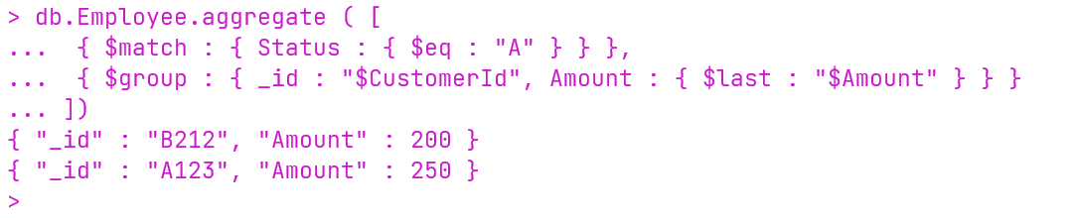

9. Create array of amount for individual customer ID having status ‘A’
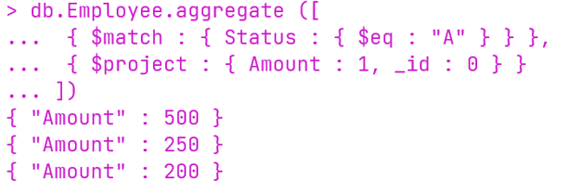

10. After sorting record find out total amount for individual customer ID

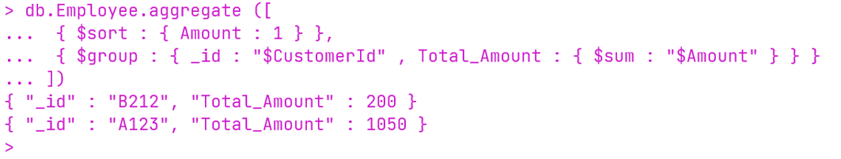

11. After sorting record find out average amount for individual customer ID

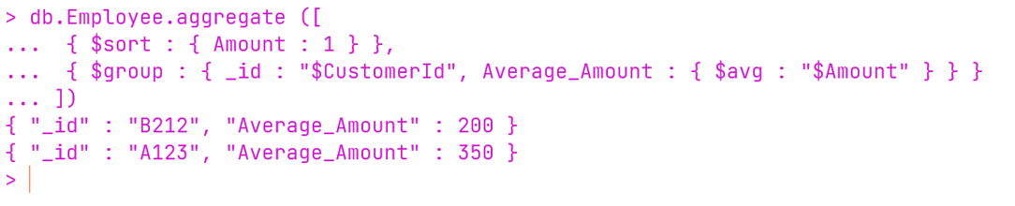

12. After sorting record find out minimum amount for individual customer ID

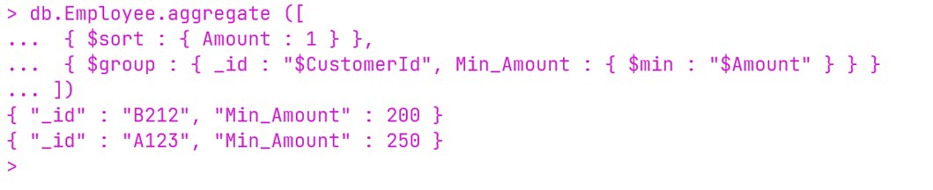

13.After sorting record Find out maximum amount for individual customer ID

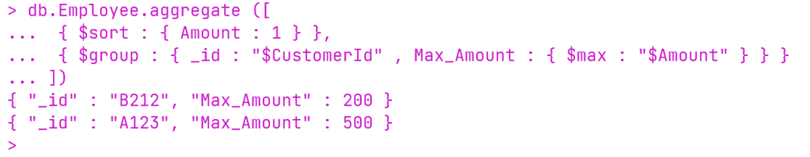

14. After sorting record find out amount of First record for individual customer ID

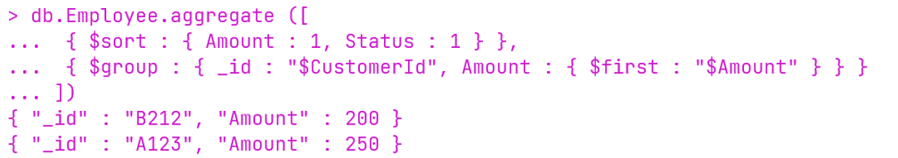

15. After sorting record find out amount of last record for individual customer ID

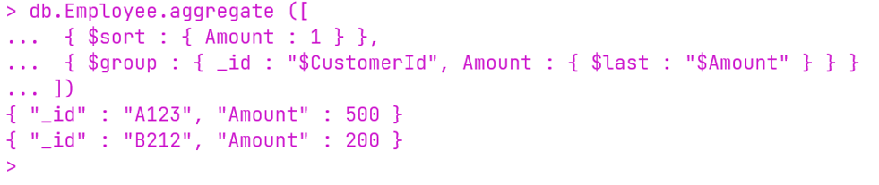

16. After sorting record create array of amount for individual customer ID

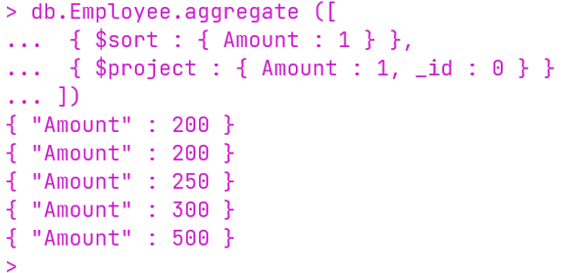

17. Without considering first record Find out total amount for individual customer ID

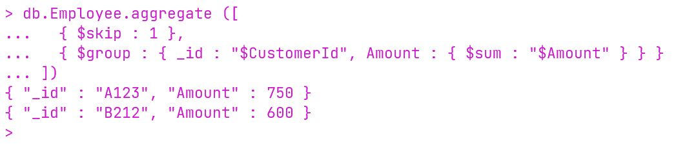

18. Without considering first record Find out average amount for individual customer ID
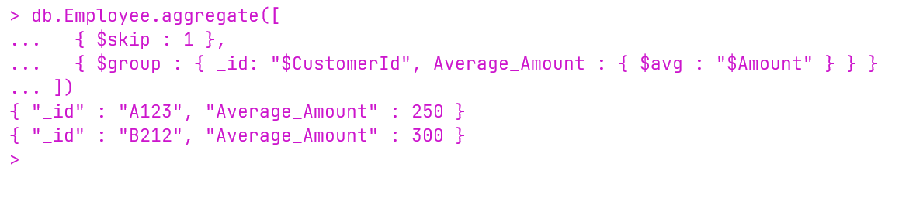

19. Without considering first record Find out maximum amount for individual customer ID

20. Without considering first record Find out minimum amount for individual customer ID

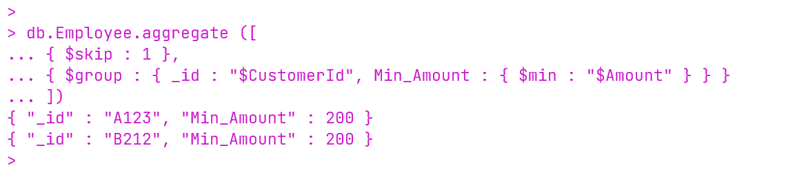

21. Without considering first record create array of amount for individual customer ID

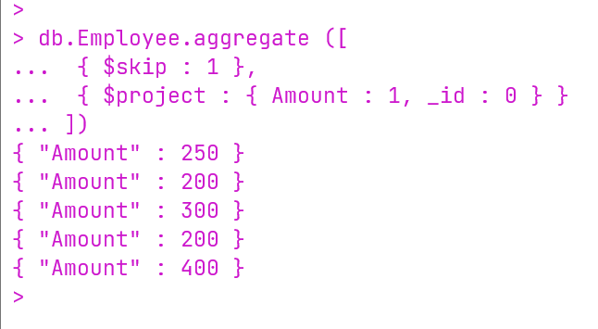

22. Without considering first record Find out amount of First record for individual customer ID

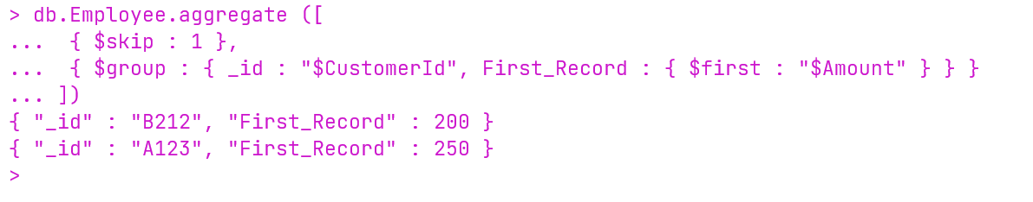

23.Without considering first record Find out amount of last record for individual customer ID

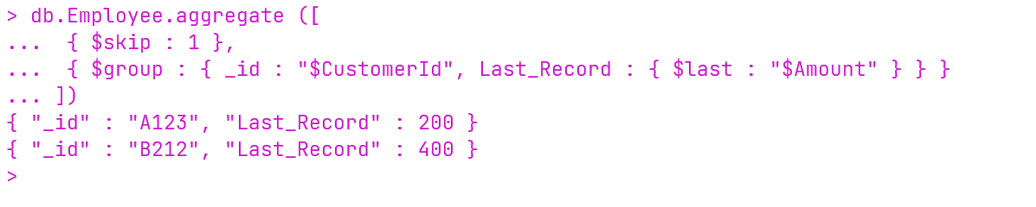

24.Just by considering first 4 records Find out total amount for individual customer ID

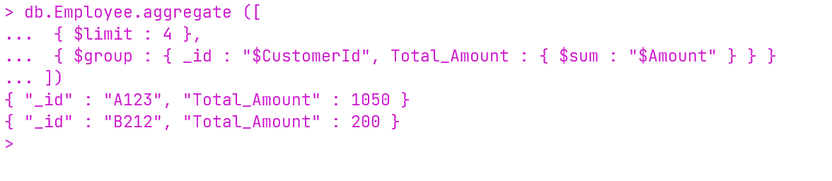
25. Just by considering first 4 records Find out Average amount for individual customer ID

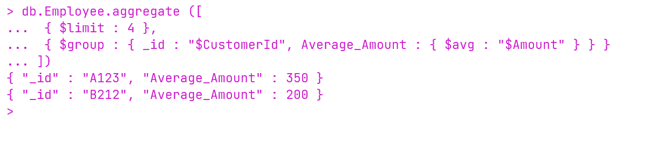
26. Just by considering first 4 records Find out minimum amount for individual customer ID

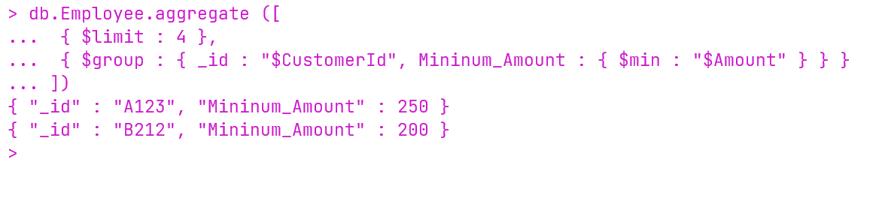
27. Just by considering first 4 records Find out Maximim amount for individual

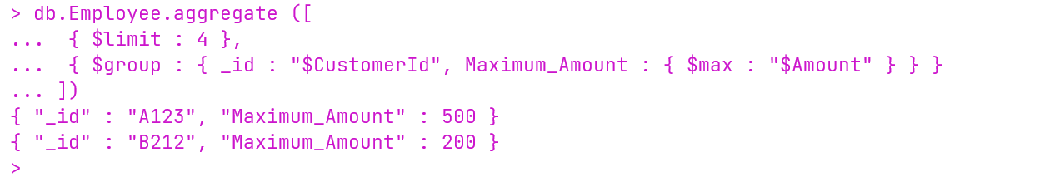

28. Just by considering first 4 records Find out amount of First record for individual customer ID

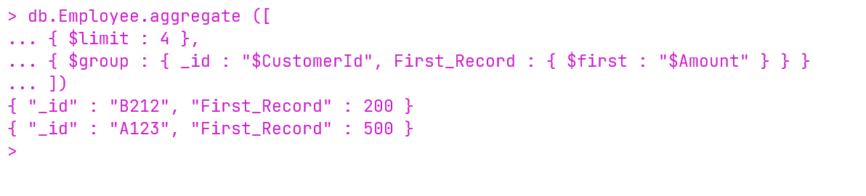
29. Just by considering first 4 records Find out amount of last record for individual customer ID

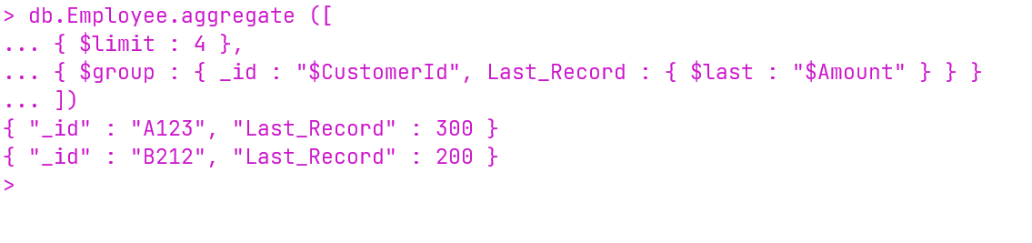
30. Just by considering first 4 records create array of amount for individual customer ID

